Database Vs Data Warehouse Vs Data Lake Vs Delta Lake

Database:
- Organized collection of data
- Used for store, retrieve, update, and delete information
- Mainly used for manage day – to – day transactions
Example:
- Customer details
- Product information
- Orders
- Payment details
- Delivery status
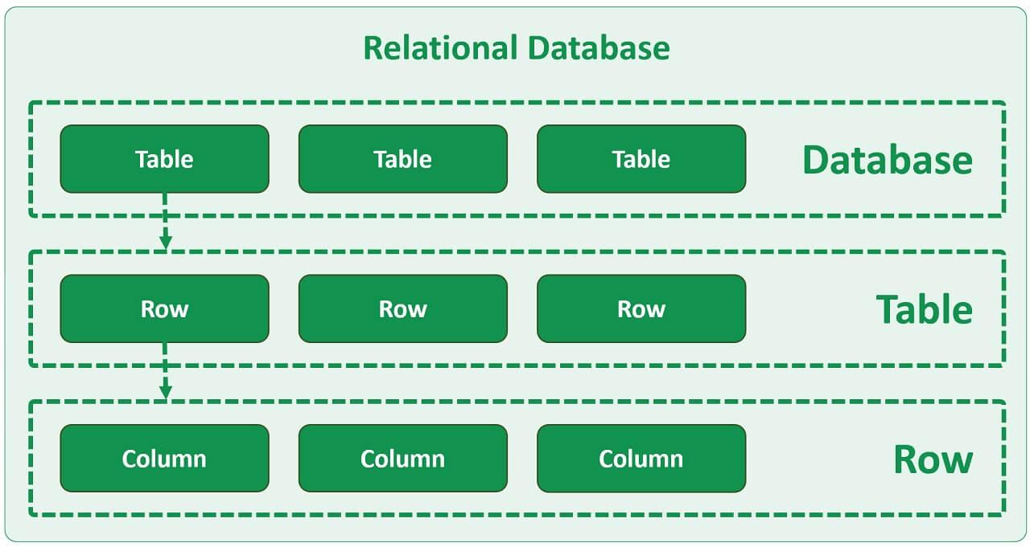

Data Warehouse:
- Centralized storage system that collects data from varies sources, organize it and store it for analysis and reporting.
- Used for historical data analysis and business decision-making.
Example:
An e-commerce company wants to analyse:
- Total sales in 2025.
- Which product generated the highest revenue?
- Which month had the most orders?
- Which city has the highest number of customers?
Data from different databases is collected, cleaned, transformed, and loaded into the warehouse.
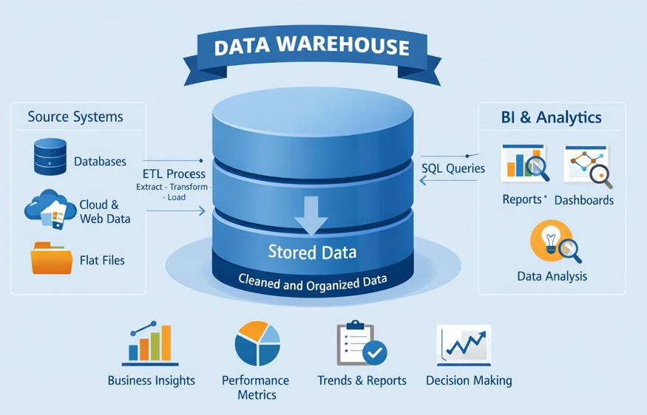

Data Lake:
- Centralized storage system that stores large amount of raw data in its original format.
- It can store different types of data:
Structured data – SQL tables, CSV files.
Semi-structured data – JSON, XML.
Unstructured data – Images, videos, audio, documents.
Example:
An e-commerce company collects:
- Customer transaction CSV files.
- Website clickstream JSON files.
- Product images.
- Customer feedback.
- Application log files.
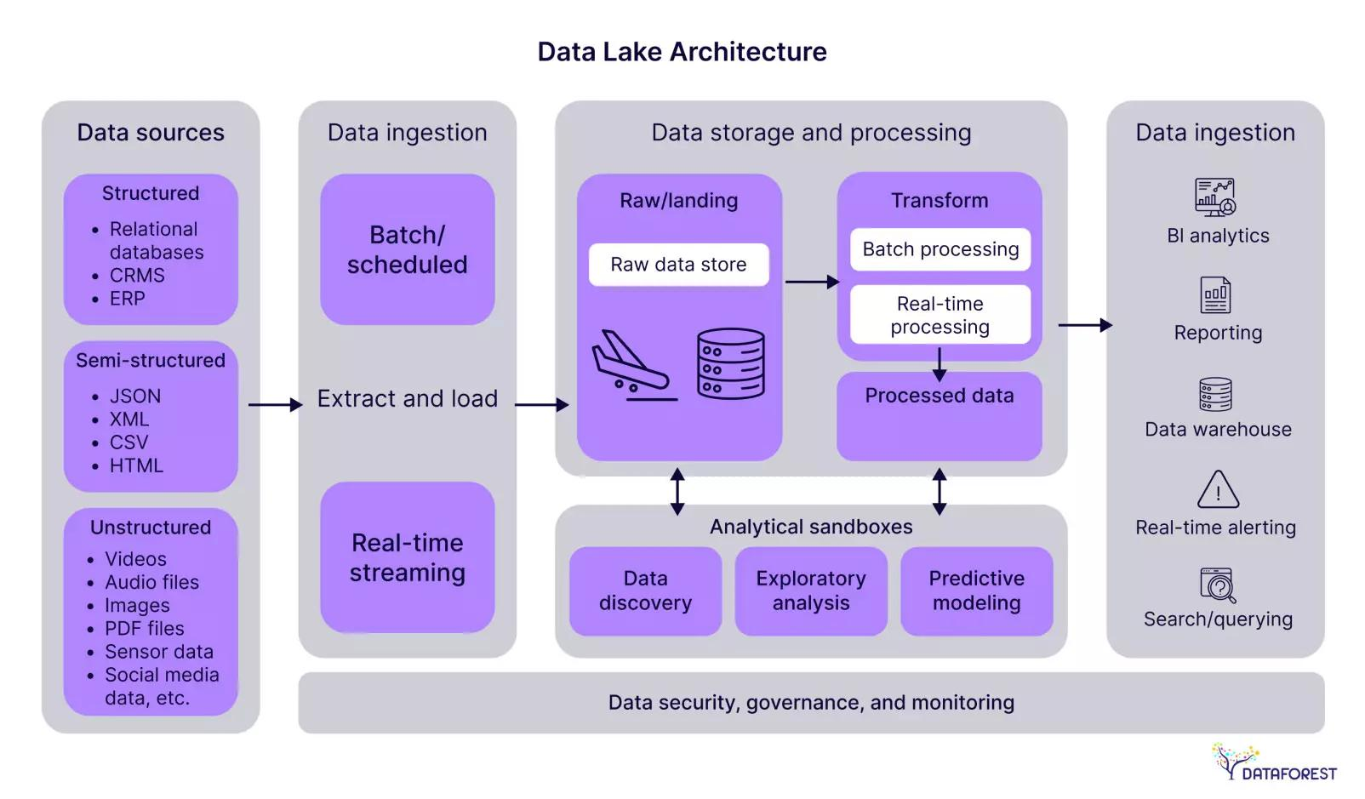
Delta Lake:
- Open-source storage framework that adds reliability and advanced features to data lakes.
- It uses Parquet files to store data and a transaction log to track changes made to the data
- Provides
ACID property - Ensures reliable and consistent data operations.
Time Travel – Access previous versions of data
Schema enforcement - Prevents unexpected data structures.
Example:
SELECT *
FROM customers VERSION AS OF 0;
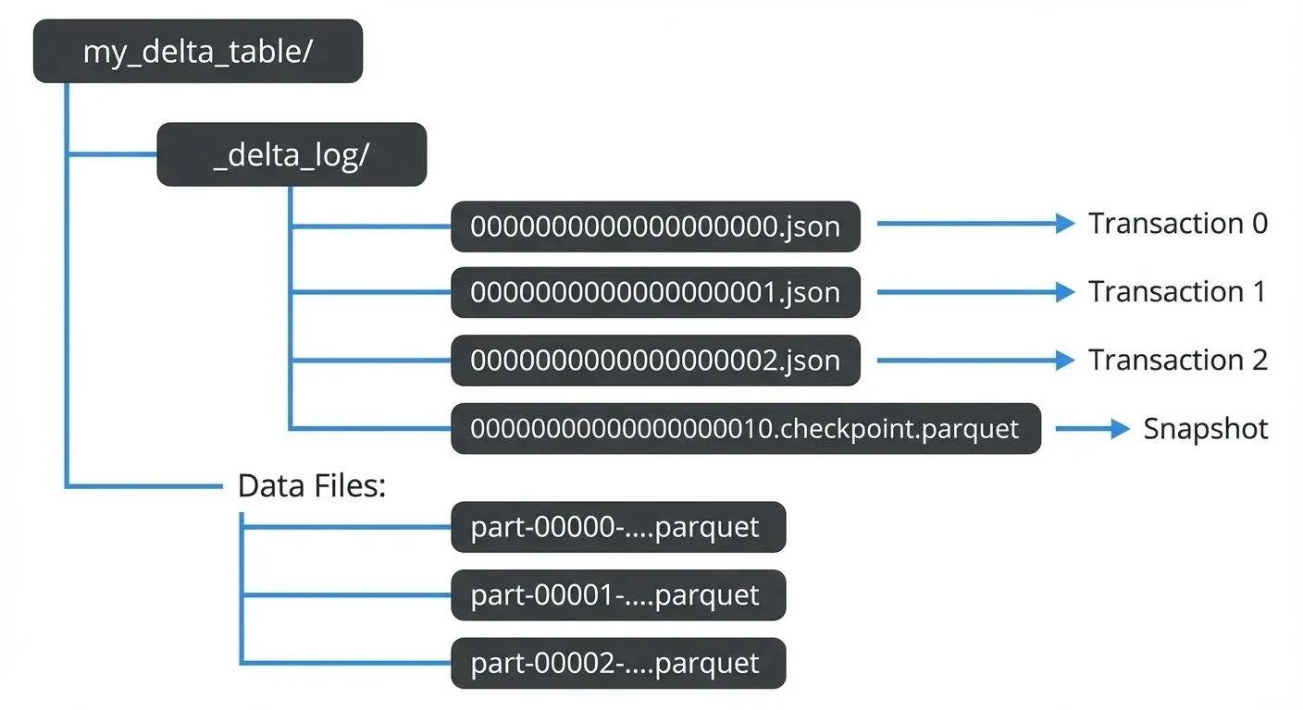
Feature | Database | Data Warehouse | Data Lake | Delta Lake
Main purpose | Transactions | Analytics | Raw data storage | Reliable lake storage
Data type | Mostly structured | Structured | All types | Structured, semi-structured
Data format | Tables | Tables | CSV, JSON, Parquet, etc. | Parquet + transaction log
Data processing | OLTP | OLAP | Often before analysis | Supports reliable processing
Schema | Schema-on-write | Schema-on-write | Often schema-on-read | Schema enforcement/evolution
Example | MySQL | Snowflake | ADLS | Delta Lake

What are ACID properties with example:
A – Atomicity
C – Consistency
I – Isolation
D – Durability

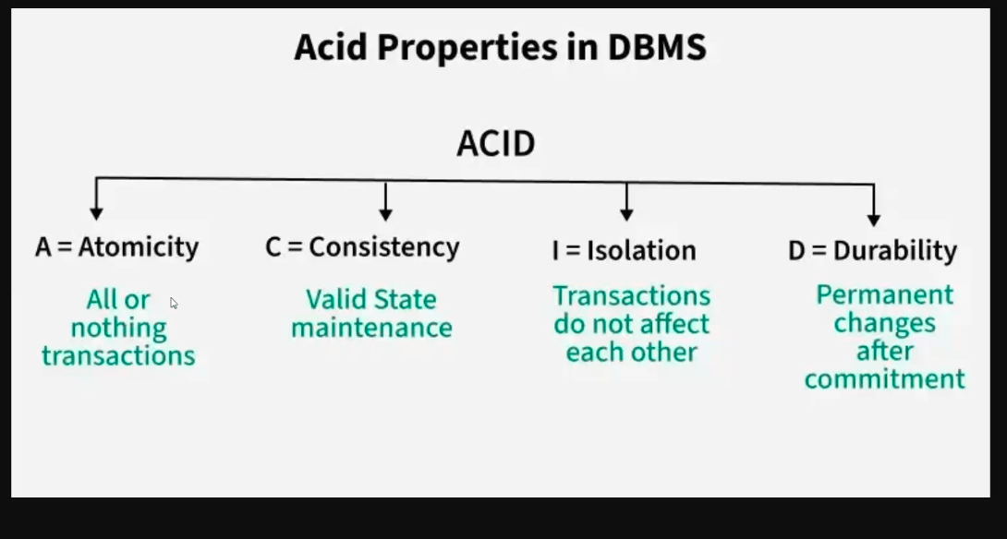

ACID properties ensure that database transactions are processed reliably and accurately, even when errors or system failures occur.
1.Atomicity (All or Nothing)
A transaction must be completed entirely or not executed at all.
Example: Bank money transfer
Suppose Arun transfers ₹1,000 to Priya.
Initially:
- Arun's balance = ₹5,000
- Priya's balance = ₹2,000
Two operations happen:
- Deduct ₹1,000 from Arun's account.
- Add ₹1,000 to Priya's account.
What if the system crashes after deducting money from Arun but before adding it to Priya?
Atomicity ensures that the entire transaction is rolled back.
Final balances:
- Arun = ₹5,000
- Priya = ₹2,000
Or, if both operations succeed:
- Arun = ₹4,000
- Priya = ₹3,000
2. Consistency (valid Data)
Transaction should move from one valid state to another valid state.
Example:
Bank account balance
Suppose a bank requires that an account balance cannot be negative.
Initial balance = ₹2,000.
A customer tries to withdraw ₹3,000.
The transaction should be rejected because it violates the database rule.
The balance remains ₹2,000.
3.Isolation (Independent Transactions)
Multiple transactions can happen at same time but they should not interfere with each other
It should execute independently
Example: Two customers booking the same seat
Imagine a movie theatre has only one seat available.
Two customers try to book the same seat simultaneously.
Without proper isolation:
- Customer A selects seat A10.
- Customer B selects seat A10.
- Both may receive a successful booking.
With proper isolation:
- Customer A successfully books seat A10.
- Customer B receives a message that the seat is already booked.
4.Durability (Permanent Changes)
If transaction successfully committed, the changes must be permanently saved, even if the system crashes or restarts.
Example: Online payment
You pay ₹2,000 for an online shopping order.
The payment transaction is successfully committed.
Immediately after that, the server crashes.
After the server restarts:
- Payment status should remain successful.
- The transaction record should still exist.
- The payment should not disappear.
Property | Meaning | Example
Atomicity | All or nothing | Money transfer
Consistency | Maintains valid data | Balance cannot be negative
Isolation | Transactions don't interfere | Two customers booking one seat
Durability | Committed changes remain | Payment survives server crash

What is Time Travel in Delta Lake?
- Access and retrieve previous versions of a table
Example: we can get the older versions of a table even after update and delete
It is useful for:
- Recovering previous data.
- Comparing old and new records.
- Auditing data changes.
- Debugging data processing errors.

Code:
SELECT *
FROM employees VERSION AS OF 0;

SELECT *
FROM employees
TIMESTAMP AS OF '2026-11-04 10:30:00';

What is a Transaction in Database?
- Group of one or more database operation that are executed as single logical unit of work.
Example: send amount 1000 from Arun to Priya
Database operation:
Deduct ₹1,000 from Arun's account.
Add ₹1,000 to Priya's account.
Both operations should succeed together.
If the first operation succeeds but the second operation fails, the database should undo the first operation.
This entire process is called a Transaction.

SQL:
BEGIN TRANSACTION
COMMIT
ROLEBACK

Merge and Upsert



